User Manual – Pre-Processing using graphical user interface

Jaianth Vijayakumar

5.4.2020

1. **Open a terminal – type “cd Desktop/pynx/Pynx_version_1/Pre_processing” (check with local contact to know the exact folder)**

– This folder has all the python files as well as an executable bash file to carry out pre-processing with a possibility to perform pynx reconstruction simultaneously.

1. **Type “python3 Ptycho_preprocessing.py”**

– This opens a graphical user interface (GUI) with four different options as shown in Fig 1.

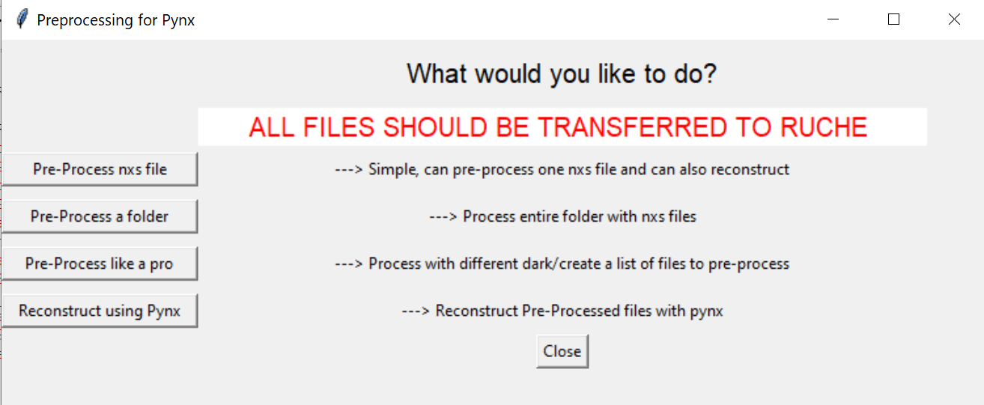

*Fig 1: Main GUI for Preprocess*

There are four options which users can choose, the first three are for preprocessing the nxs file generated during the experiment suitable for pynx reconstruction and the last option is to carry out pynx reconstruction alone. A brief description on the different options is given below:

1. “Pre-Process nxs file” – To process single or multiple files and it only requires to enter the folder, file name and the processing parameters. IMPORTANT: the nxs file, dark nxs file and the STXM hdf file must be in the same folder.
2. “Pre-Process a folder” – To process a folder, it requires the user to enter the folder and the pre-processing parameters. This option is suitable when processing a ptycho – XAS. IMPORTANT: the nxs file, dark file and the STXM hdf file must be in the same folder.
3. “Pre-Process like a pro” – This option should be used under exceptional cases, for example when the user want to process the file with different dark nxs file or STXM file. This options requires the users to input folder and file names of nxs files, dark file and STXM hdf file separately along with the preprocessing parameters.
4. “Reconstruct using Pynx” – To reconstruct a pre-processed cxi to obtain the ptychography images. This is still under development as of 5.4.2020.
5. **Option 1: Pre-Process nxs file:** By clicking this option, a new window opens shown in Fig 2. The main window opened and shown in Fig 1 should be **KEPT OPEN** all the time during preprocessing.

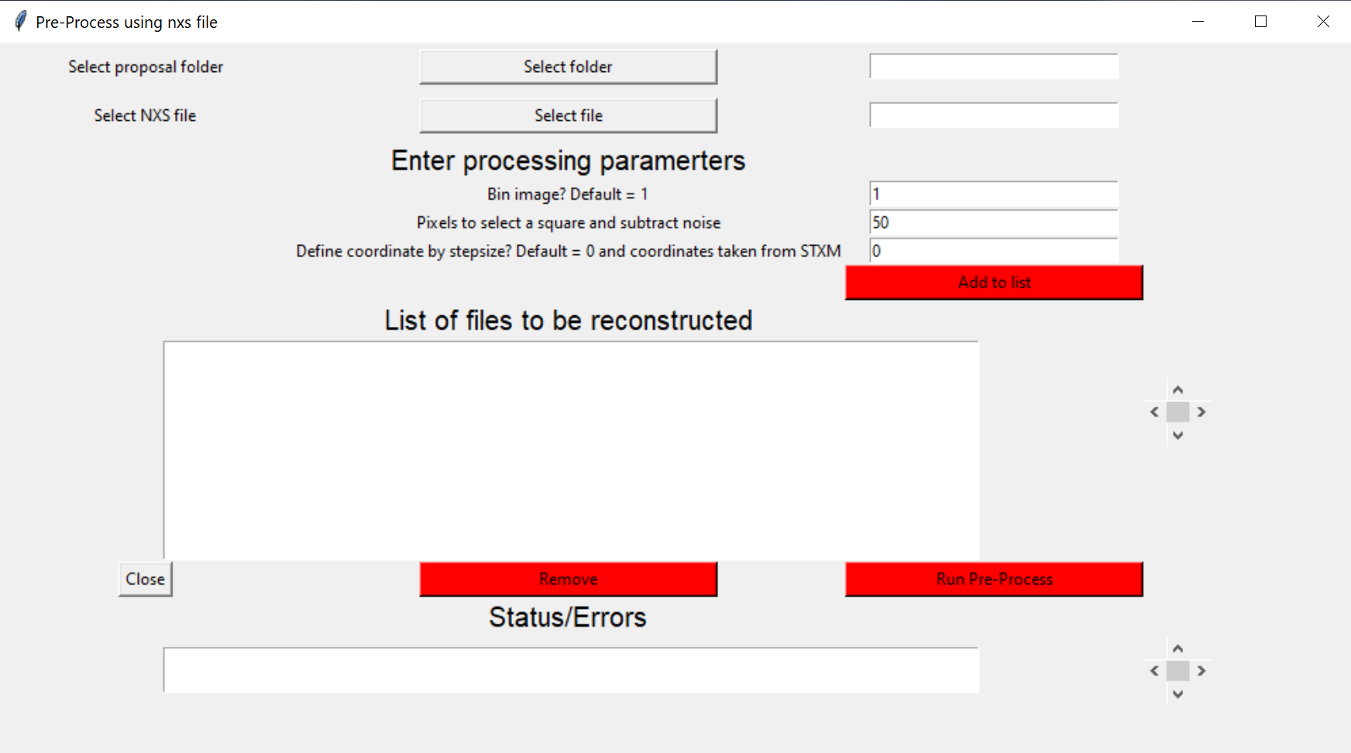

*Fig 2: Option 1 – “Pre-Process using nxs file*

**Input parameters**:

**Folder**: Press the “Select folder” button opens a window choose the right folder. Once chosen the path will appear on the field on the right.

**File**: Press the “Select file” button and choose the nxs file, an example of nxs file is “si107_20191201_000001.nxs” (Note: using this file name, the names of the dark and the STXM file is generated to pre-process the file.)

**Bin image? Default =1**: In case the diffraction pattern is big such that the entire 2048 x 2048 pixels were used, reduce to 1024 x 1024 by entering the binning value as 2. This is necessary as the pynx reconstruction was not able to handle 2048 x 2048 dimension due to memory issues. However, this can be checked during the reconstruction if necessary.

**Pixels to select a square and subtract noise:** This option is to remove the electrical noise on the camera. Although most of the background is subtracted by the dark image removing the additional noises in useful for better reconstruction. Depending on the spread of the diffraction pattern use the appropriate values as recommended in table 1. If the diffraction signal is not spread over the entire image use higher value.

|  |  |
| --- | --- |
| Image size | Recommended value |
| 1024 x 1024 | 50 – 100 |
| 512 x 512 | 25 - 50 |

Table 1: Value to use with image size

**Define coordinate by step size? Default = 0 and coordinates take from STXM:** To use the coordinate system recorded in the STXM file enter “0” otherwise to generate coordinate system enter the sstep size used during the data acquisition. Both systems would work for the pynx reconstruction.

* 1. Press “**Add to list**” once all the values have been entered. The parameters would then appear in the “**List of files to be reconstructed**” an example is shown in Fig 3. Each parameter is separated by **five underscores** (“_”), it is from here that the values are then taken to carry out the pre-processing. One can add as many number of files required, by using the scroll bars on the right the lists can be moved in all direction to check the files. If the files are missing an error message will appear in the bottom inside “Status/Errors”.
  2. “**Remove**” – To remove a file from the list, select the field and press “Remove”. Note: the file number appearing on the extreme right as the first parameter will not be updated.
  3. Press “**Run Pre-Process**” to start the pre-processing. As soon as each files are processed the status will be updated in the “Status/Errors” as finished 1/1 files along with the file name.
  4. To see the old error/status messages press the down button on the scrollbars on the right. **IMPORTANT: the new messages appear on the top. If you scroll down to see old messages, make sure to go back all the way to the top such that new messages/status will start to appear.**

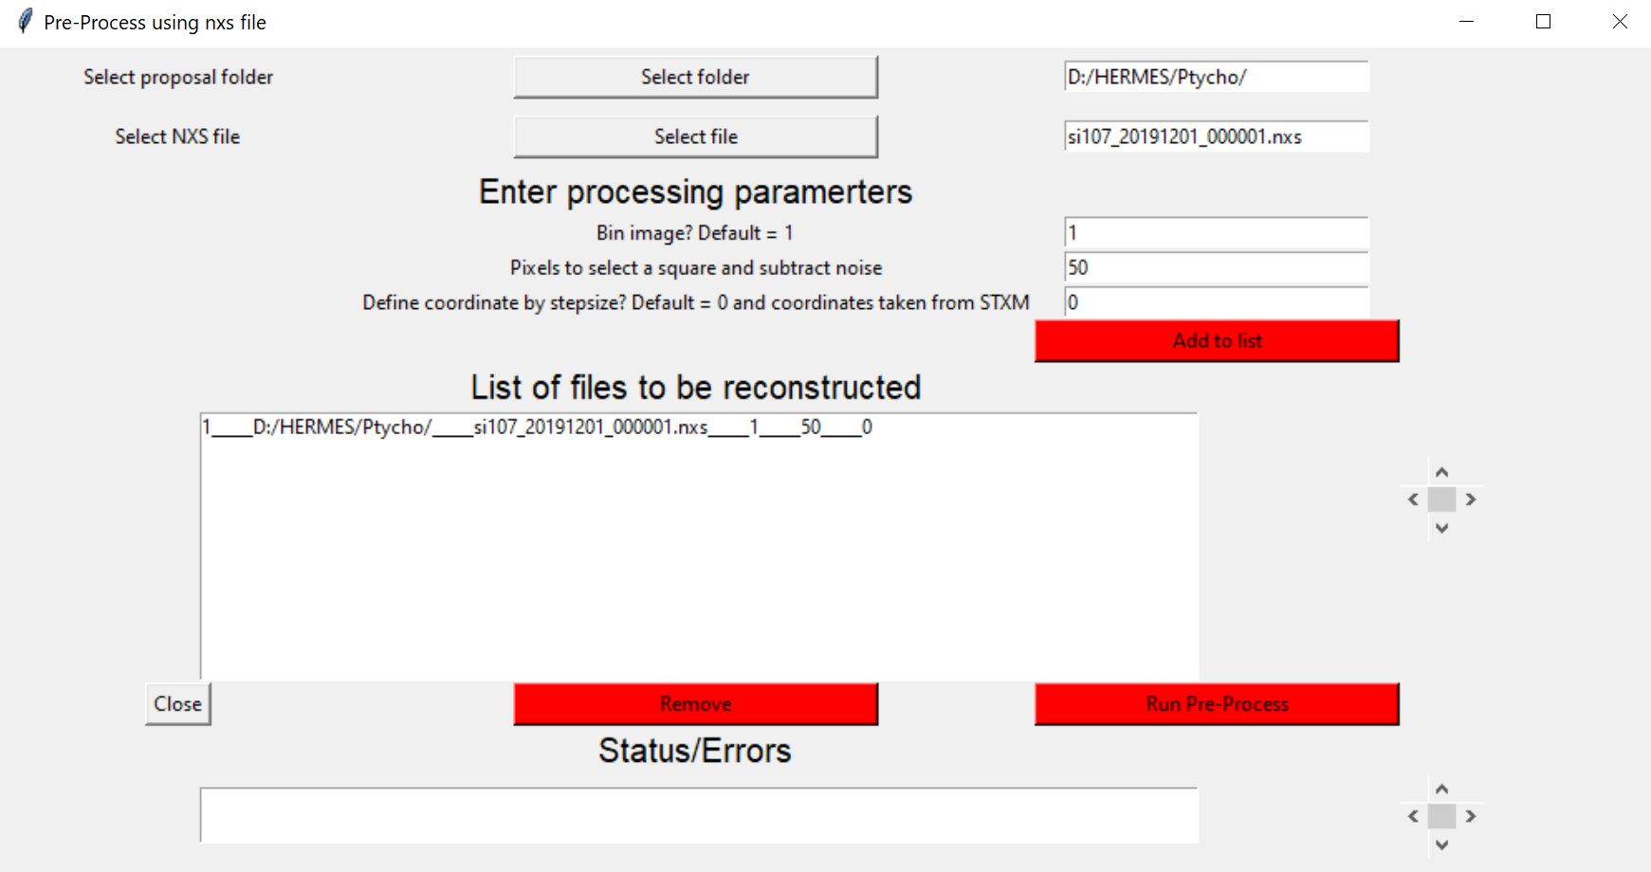

*Fig 3: Layout after adding the parameters*

1. **Option 2: Pre-Process a folder:** Clicking the second option “Pre-Process a folder” opens a new window shown in Fig 4. The main window opened and shown in Fig 1 should be **KEPT OPEN** all the time during preprocessing.

**Input parameters:**

**Folder**: Press the “Select folder” button opens a window choose the right folder. Once chosen the path will appear on the field on the right. Make sure that the nxs files, dark files and STXM files are stored in the same folder.

**For Bin image? Default =1**, **Pixels to select a square and subtract noise, Define coordinate by step size? Default = 0 and coordinates take from STXM –** **refer the link** **(if the link is not working, scroll up to the previous page)**

4.1 Once the folder has been selected, press “**Add nxs files to list**” this option identifies all the nxs files and list in the “List of files to be reconstructed”. In addition under “Status/Errors” number of nxs files in the folder will be displayed. Files can be removed by selecting the file and pressing “**Remove**”. Start the pre-process by pressing “**Pre-Process folder**”. **IMPORTANT: the new messages appear on the top. If you scroll down to see old messages, make sure to go back all the way to the top such that new messages/status will start to appear.**

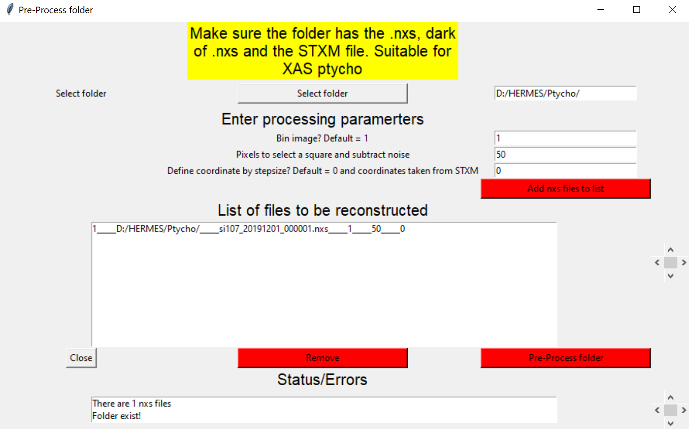

*Fig 4: Layout of Pre-Process folder*

1. **Option 3: Pre-Process like a Pro:** the layout of this option is shown in Fig 5. Here one can define all the files and folders separately. By pressing “**Add to list**” the files, folders and the parameters are then shown in the “**List of files to be reconstructed**”. Refer link to determine the input values necessary in this process (if the link does not work, scroll up to page 2 for referring input parameters). Add as many files as needed, press “**Pre-Proces**” to start the process. To remove file press the appropriate files and press “**Remove**”.

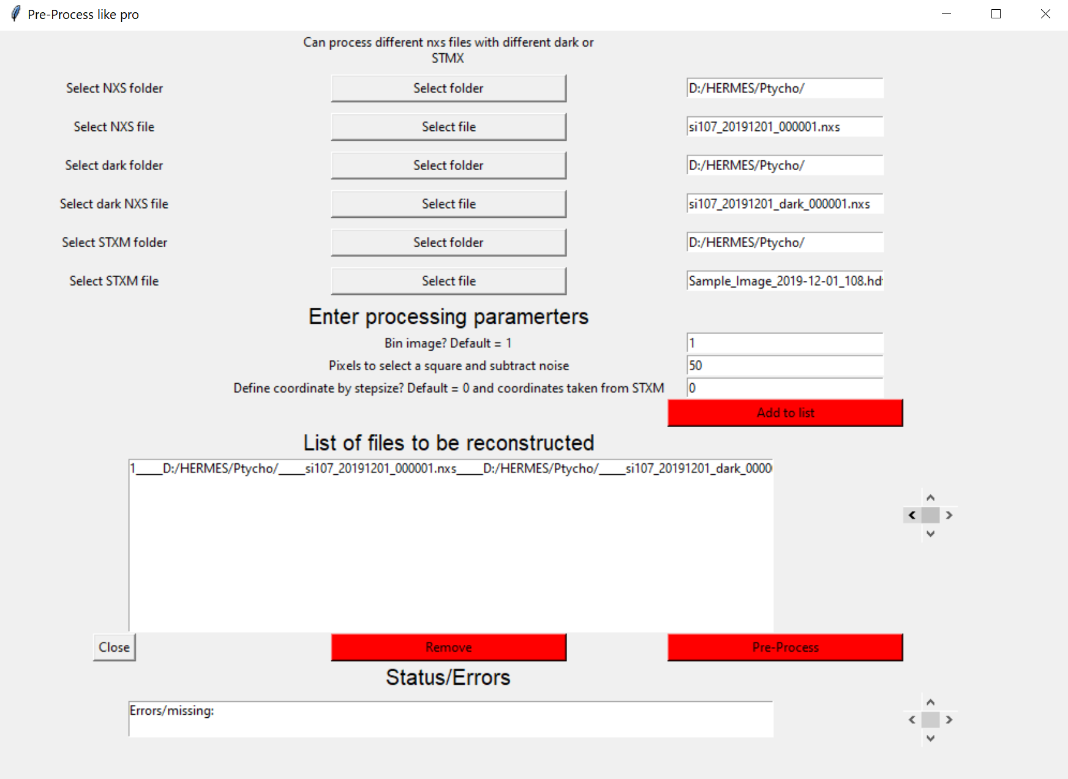

*Fig 5: Layout of Pre-Process like a folder*

Files and Format at HERMES beamline Ptychography setup

Jaianth Vijayakumar

5.4.2020

At HERMES the ptychography experiment will produce a .nxs file with the data of the diffraction pattern, .nxs dark file with the data acquired without the beam and STXM hdf file generated from the pixellator software. To carry out the reconstruction all these files are necessary for reconstruction. These files are all stored in the same user proposal folder. The contents of the nxs file and nxs dark file is shown in Fig 1 and Fig 2 respectively.

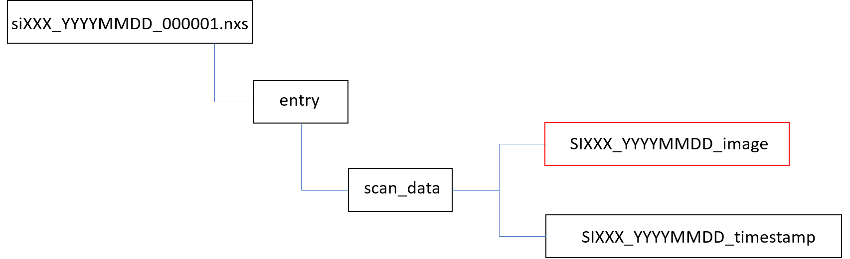

*Fig 1: NXS image file tree. The dataset with red box is used for pre-processing*

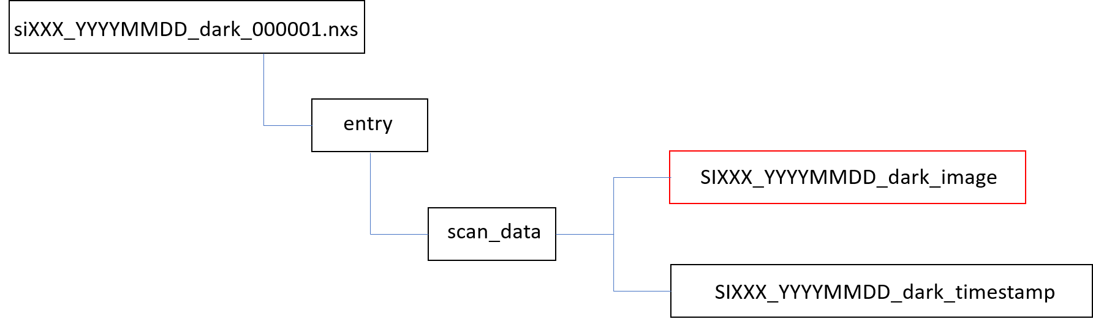

*Fig 2: NXS dark image file tree. The dataset with red box is used for pre-processing*

For Pynx reconstruction the coordinates of the individual diffraction pattern is required, therefore we extract the coordinates from the STXM file. The STXM file has the file number which +1 to the nxs file. For example, si107_20191201_000001.nxs has STXM file as Sample_Image_2019-12-01_108.hdf5. The contents of the STXM file which will be used for the preprocessing is shown in Fig 3, the hdf file also has other information however, only the dataset shown in Fig 3 is used to create the final .cxi file for preprocessing.

Finally after the preprocessing the output .cxi is produced with the necessary image processing. The contents of the cxi file is shown in Fig 4. The output cxi file would have the name of nxs followed by energy, polarization and the suffix “pre_processed”. If the nxs file is preprocessed for more than once (assuming that the output cxi file is stored in the same folder as the previous preprocessed file) the date and time will be inserted before the “pre-processed” suffix. The date and time will have the form “month_day_year__hour_minutes_seconds”, this will avoid overwriting of the file.

The cxi file has three main groups as shown in Fig 4, namely “data”. “STXM image” and “Miscellaneous”. For pynx reconstruction the necessary data can be found in the “data” group. The “data” group has the dataset “image_data” which has the processed diffraction pattern, the coordinates stored in dataset “Coordinate_X” and “Coordinate_Y” and Energy. These are the four main parameters required for the pynx reconstruction. The remaining data will serve as reference . The dataset “probe_mask” is generally used for the SHARP reconstruction, however for pynx reconstruction this mask may not be necessary. **NOTE: A mask is only needed to remove noise or fake pixels from the detector/image!**

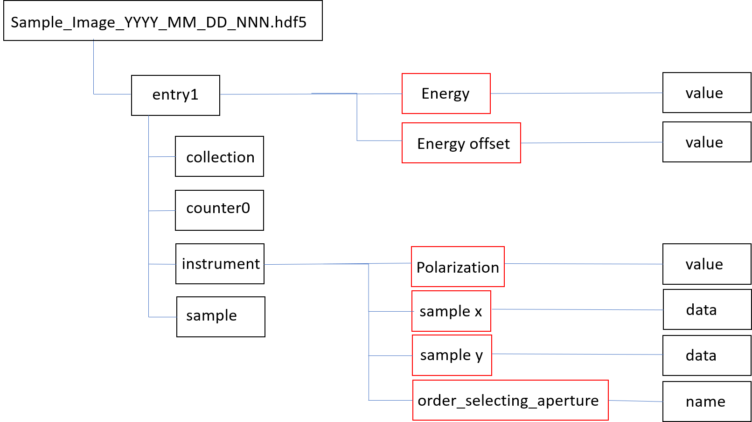

*Fig 3: STXM hdf file. The dataset with red box is used for pre-processing*

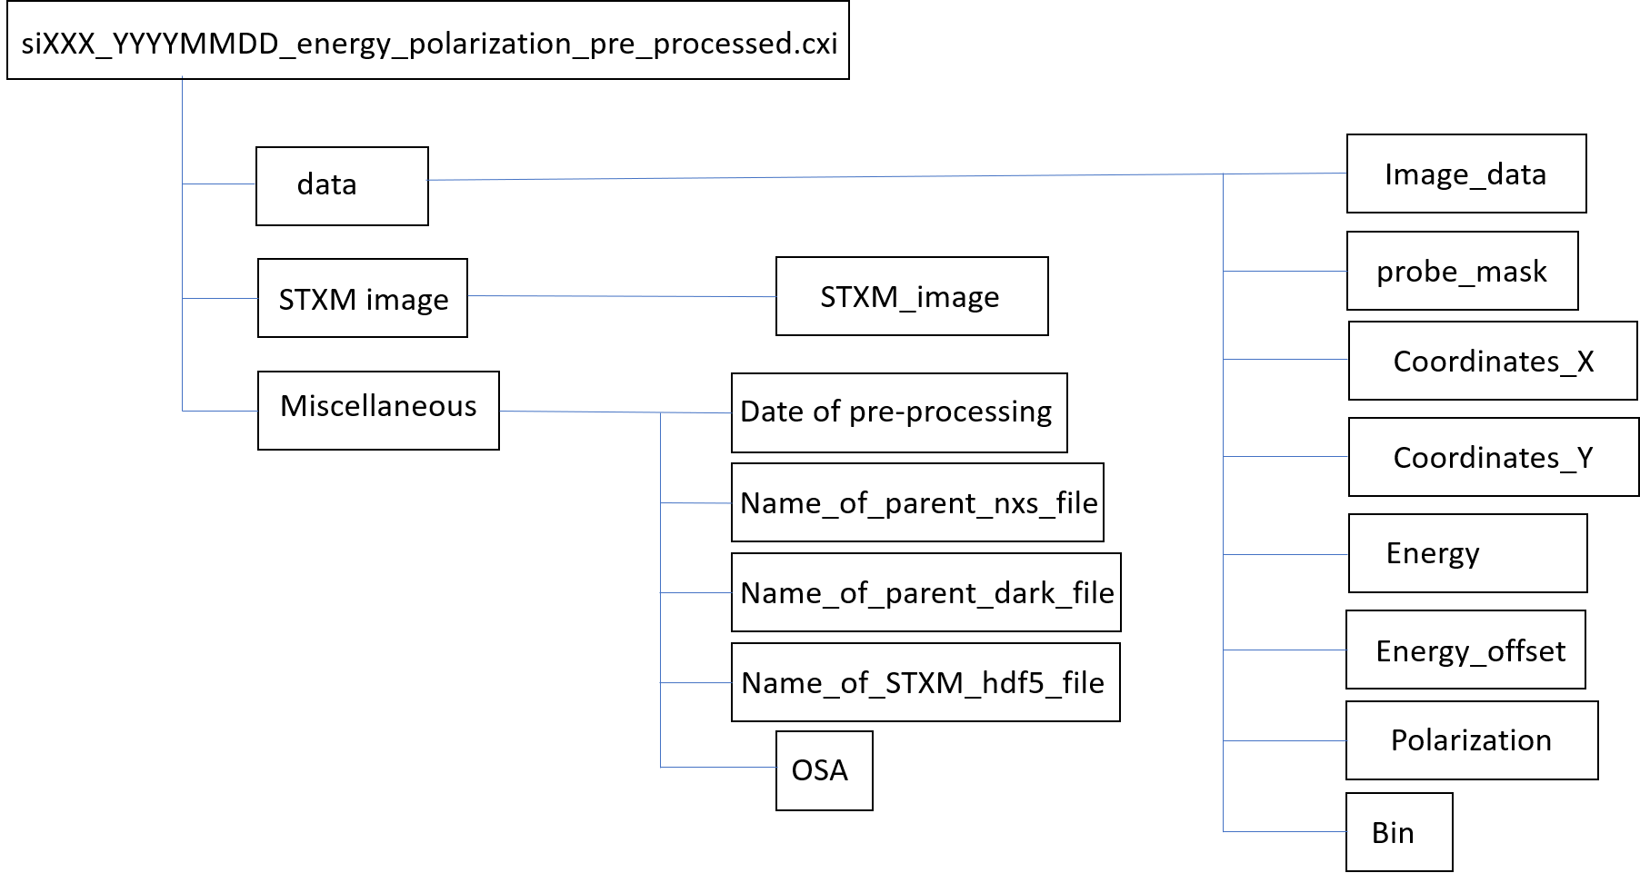

*Fig 4: The contents of the pre-processed cxi file to be used for pynx reconstruction.*